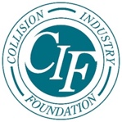

CIF Reflects on Success of 10th Annual Gala Fundraiser

March 20, 2020 – Mechanicsville, VA - The Collision Industry Foundation (CIF) saw record attendance for the 10th annual Gala Fundraiser in Palm Springs, Calif. on January 16 at “The Bank” event site.
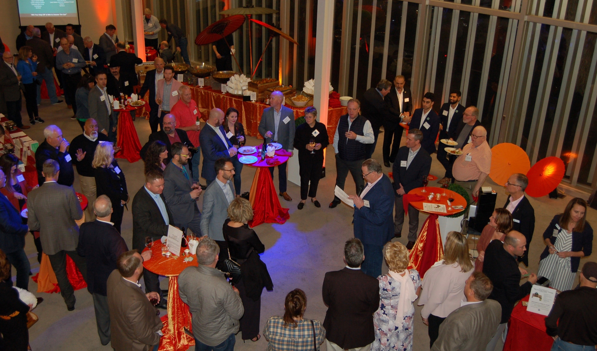
The new location was selected to accommodate an increasingly larger crowd, which proved useful as a record number of attendees enjoyed a cocktail party. The event featured cuisine from LuLu’s California Bistro, lively music, and the chance to network with other industry professionals.
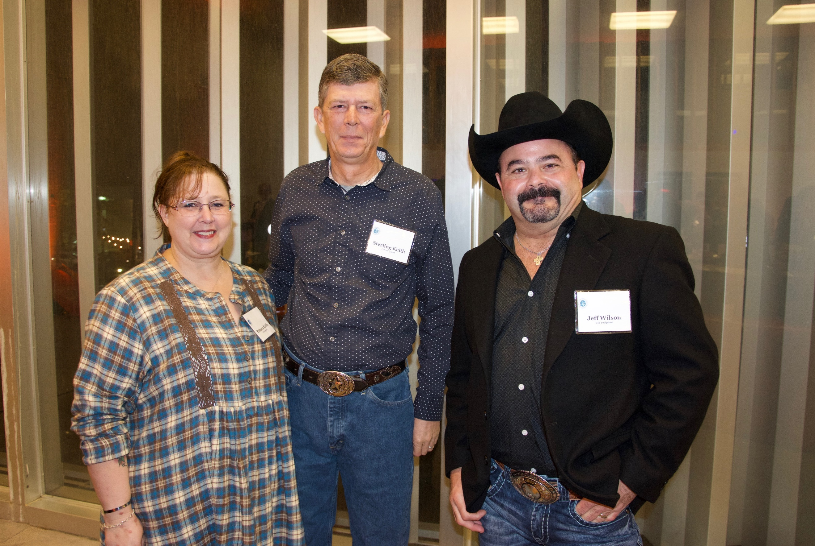
(R-L) CIF Recipients Jeff Wilson, Sterling and Rebecca Keith

The Gala offered a rare opportunity to meet former recipients of the Foundation’s support. Jeff Wilson, an instructor at Houston’s Kingwood Park High School, that received CIF support after being impacted by Hurricane Harvey, and Veteran Sterling Keith, who received support from CIF and Snap-on to replace his tools and Toolbox that were stolen while he was deployed.

The goal of the annual Gala event is to raise funds to provide assistance when industry professionals are impacted by natural disasters or other catastrophic events. CIF is thrilled to share they have a record number of donors in 2020. A full list of all donors can be found on the CIF website at collisionindustryfoundation.org.

In addition to monetary support, donors contributed almost two dozen items as raffle and silent auction items. The highly coveted, special drawing prize of a Big Green Egg Smoker, valued at $1,500 and donated by Nexsyis, was won by Lonnie Margol.

To kick off the evening, Michael Quinn, CIF President and SVP of Business Development at AirPro Diagnostics, welcomed the crowd and thanked everyone for their support. “CIF is able to provide the assistance that we do through your generosity” Quinn said as he addressed the attendees. “This industry has an enormous heart, which you continue to demonstrate year-over-year, and the CIF Board is truly humbled to be allowed to assist our brothers and sisters in need on your behalf.”

Quinn then welcomed all former CIF trustees present and introduced the 2020 CIF Board of Trustees.
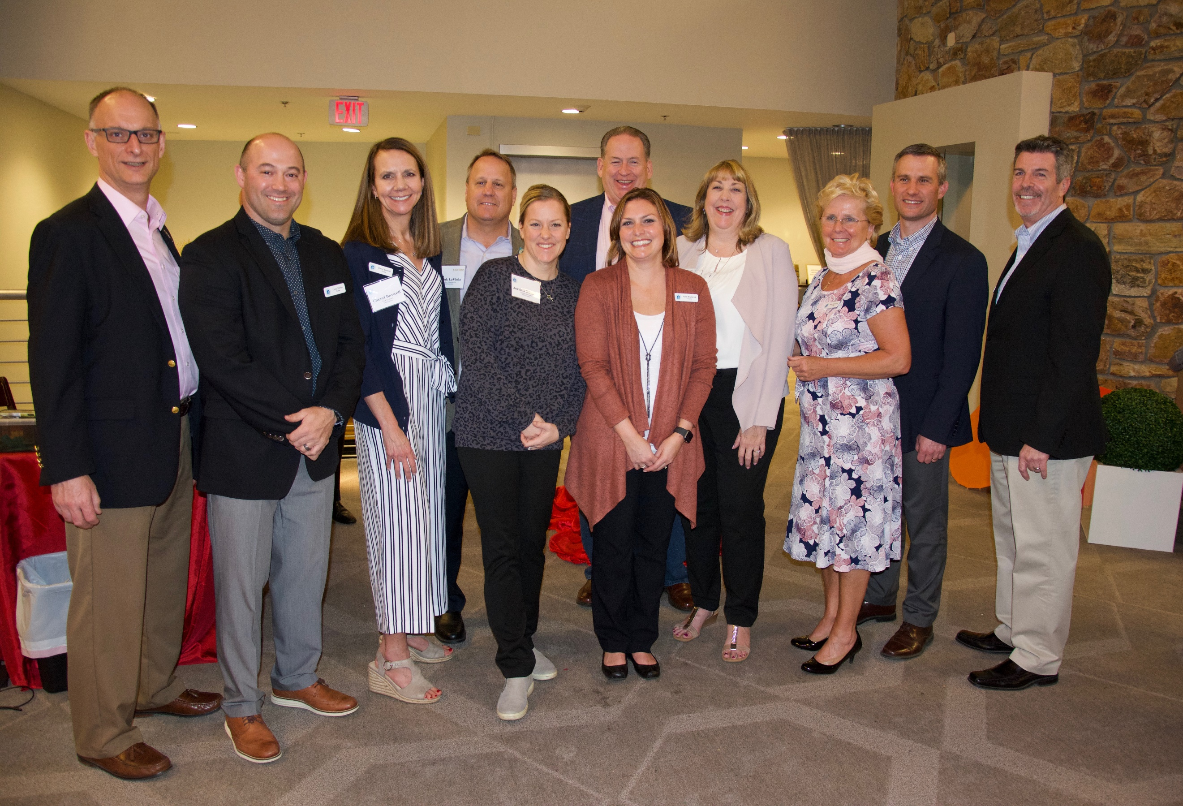
CIF Board of Trustees, click here for full information

Thanks to the success of the 10th annual Gala, and all the generous CIF donors, the organization will continue to fulfill its vision and mission into the future.

About CIF: The Collision Industry Foundation (CIF) is the 501(c)(3) charitable arm of the collision repair industry. We are dedicated to raising, managing, and donating funds to provide emergency relief to collision repair professionals who have been impacted by natural disasters or other catastrophic events.

For more information visit: http://www.collisionindustryfoundation.org
Like us on Facebook and Follow us on LinkedIn

