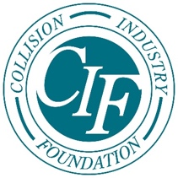
Collision Industry Foundation Announces
Fund Established for COVID-19 Victims
We answer the call®

March 26, 2020 - Mechanicsville, VA. - The Collision Industry Foundation (CIF) announced today the formation of a specific fund to assist those within the industry impacted by the Coronavirus, or COVID-19.

On behalf of the industry, CIF has committed to initially fund $100,000 in assistance to help individual collision repair professionals and their immediate families dealing with the effects of the virus.

“Our hearts go out to all those impacted by this worldwide pandemic,” expressed Michael Quinn, CIF Board President and SVP of Business Development at AirPro Diagnostics. “The CIF is prepared to step forward with an initial commitment of $100,000 and encourages all stakeholders in the industry to contribute and support collision repair employees, technicians and their families in the face of this crisis. 100% of your tax-deductible donations to CIF from now through May will be added to this COVID-19 fund, so we can help as many members of our industry as possible.”

If you need help, know someone that needs help or want to make a tax-deductible donation please:
TO DONATE - Click Here

TO APPLY FOR ASSISTANCE - Click Here

About CIF: The Collision Industry Foundation (CIF)is the 501(c)(3) charitable arm of the collision repair industry. CIF is dedicated to raising, managing and donating funds to provide emergency relief to collision repair professionals who have been impacted by natural disasters or other catastrophic events.
For more information visit: http://www.collisionindustryfoundation.org
Like us on Facebook and Follow us on LinkedIn

